# 

# An incubated co-working space for technology innovation

## NFV Proposal

**Working Document**

**Table of Contents**

1

An incubated co-working space for technology innovation 1

NFV Proposal 1

Document Change Log ii

Definition of Terms iii

Team Register iii

Description of Acronyms iv

1 DOCUMENT OVERVIEW 1

1.1 INTRODUCTION & PROBLEM STATEMENT 1

1.2 SCOPE 1

2 SOLUTION 2

3 PURPOSE OF THE STUDY 2

4 NFV DESIGN FRAMEWORK 2

4.1 Three main ingredients 2

4.2 We will be using type 1 hypervisor 3

4.3 WHY WE CHOSE TYPE 1 HYPERVISOR 3

5 BUSINESS VALUE GENERATED BY NFV 4

6 SAMPLING AND SIMULATION PROCCESS 4

7 NFV LIMITATIONS 5

7.1 TECHNICAL LIMITATIONS 7

7.2 OPERATIONAL LIMITATIONS 7

8 BUSINESS OPPORTUNITY 7

9 NFV TIME LINE 7

# Document Change Log

This is a working document, which will be maintained with time. Team members, please ensure that any changes are recorded in the change log below – this is to ensure that each team member is always clear about which changes have been made and when.

|  |  |  |  |
| --- | --- | --- | --- |
| **Version** | **Date** | **Author** | **Description** |
| 0.01 | 21 March 2015 | Malusi Gcakasi | Created initial template document. |
|  |  |  |  |

# Definition of Terms

|  |  |
| --- | --- |
| **Term** | **Definition** |
|  |  |
|  |  |
|  |  |
|  |  |
|  |  |
|  |  |
|  |  |
|  |  |

# Team Register

|  |  |
| --- | --- |
| **Member Name** | **Role Description** |
| Mandilakhe Hlaula | Member |
| Pumza Tyotyo | Member |
| Vuyiseka Mqwala | Team Leader |

# Description of Acronyms

|  |  |
| --- | --- |
| **Acronym** | **Description** |
| CH | The Cortex Hub |
| VNF | Virtualized Network Function |
| NFV | Network Function Virtualized |
| ETSI | European Telecommunications Standards Institute |
| SDN | Software Defined Network |
|  |  |
|  |  |

# DOCUMENT OVERVIEW

The main objective for this document is to outline the problem at hand that makes the team think it is important to dig deeper and put into place the virtualization of a network, the challenges, the enablers of the network function virtualization. Also to propose the platforms to perform the demonstration of the network function virtualization when finishing the research.

## INTRODUCTION & PROBLEM STATEMENT

Network operators’ networks are populated with a large and increasing variety of proprietary hardware appliances. To launch a new network service often requires variety of boxes, finding the space to accommodate these boxes, power to accommodate these boxes leading to Increasing costs of real estate to accommodate these appliances, increasing costs of energy. Capital investment in related infrastructure, hiring manpower necessary to design, integrate and operate increasingly complex hardware-based appliances. Cost of hardware based appliances rapidly reach end of life, requiring refresh cost.

Together with the increasing costs of energy, capital investment challenges and the skills necessary to design, integrate and operate increasingly complex hardware-based appliances.

Moreover, hardware-based appliances rapidly reach end of life, requiring much of the servicing or replacing method that needs a lot of money from the organization. Worse, hardware lifecycles are becoming shorter as technology and services innovation accelerates.

## SCOPE

The team is to provide a working and demonstrable implementation of NFV by virtualising the server functions into software.

# SOLUTION

Network Functions Virtualization aims to address these problems by leveraging standard IT virtualization technology to consolidate many network equipment types onto industry standard high volume servers, switches and storage, which could be located in Datacenters, Network Nodes and in the end user premises. We believe Network Functions Virtualization is applicable and can be a great solution to the above mentioned problems.

# PURPOSE OF THE STUDY

NFV will address most of the inefficiencies and barriers to innovation that exist in current network infrastructures, and technology is something that changes to better the ways things are being done every day just to mention few examples, much as the public switched telephone network moved from all-analog, to digital for backhaul only, to nearly all digital transmission, corporate and service provider networks can move from the current status to a more efficient and manageable model. Fragmented, non-commodity hardware and physically installing appliances at each site? Gone. Simply the interest comes from how the technology changes this to be more simple, small and smart.

# NFV DESIGN FRAMEWORK

## Three main ingredients

These are the things that are the must have when implementing our virtualization, as they are the main ingredients for the network to function.

* High-power servers
* Hypervisor ESXi
* Cloud management solution such as OpenStack or VMware vSphere

THE DESIGN-METHODS AND PROCEDURES

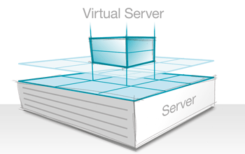

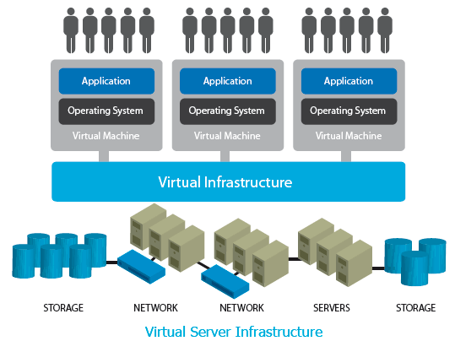

## We will be using type 1 hypervisor

Hypervisors run directly on the system hardware. It is often referred to as a "native" or "bare metal" or "embedded" hypervisors in vendor literature. Building the hypervisor into firmware, meaning the hardware is providing to be efficient.

## WHY WE CHOSE TYPE 1 HYPERVISOR

Type 1 hypervisor provides performance, availability and security

VMware ESXi is an operating system-independent hypervisor based on the VMkernel operating system interfacing with agents that run on it.

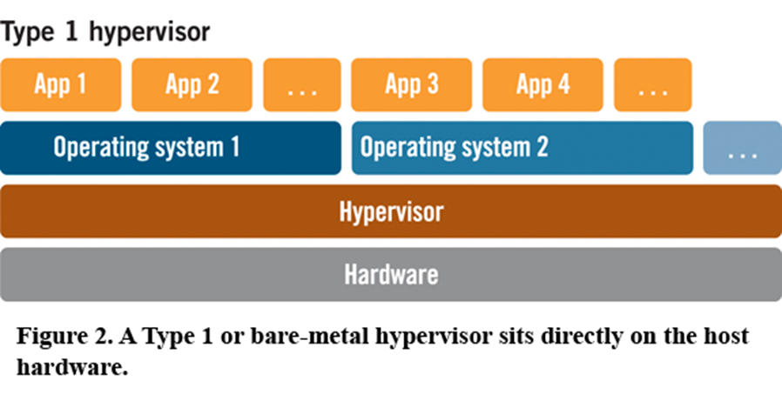

# BUSINESS VALUE GENERATED BY NFV

Software-defined networking enables operators to realize the NFV vision and value proposition, namely:

* Improved service velocity and innovation
* Optimized resource utilization
* Streamlined operations
* Unprecedented openness
* Energy-efficient operations
* Improved financial control over network operations
* Just-in-time network planning and provisioning

# SAMPLING AND SIMULATION PROCCESS

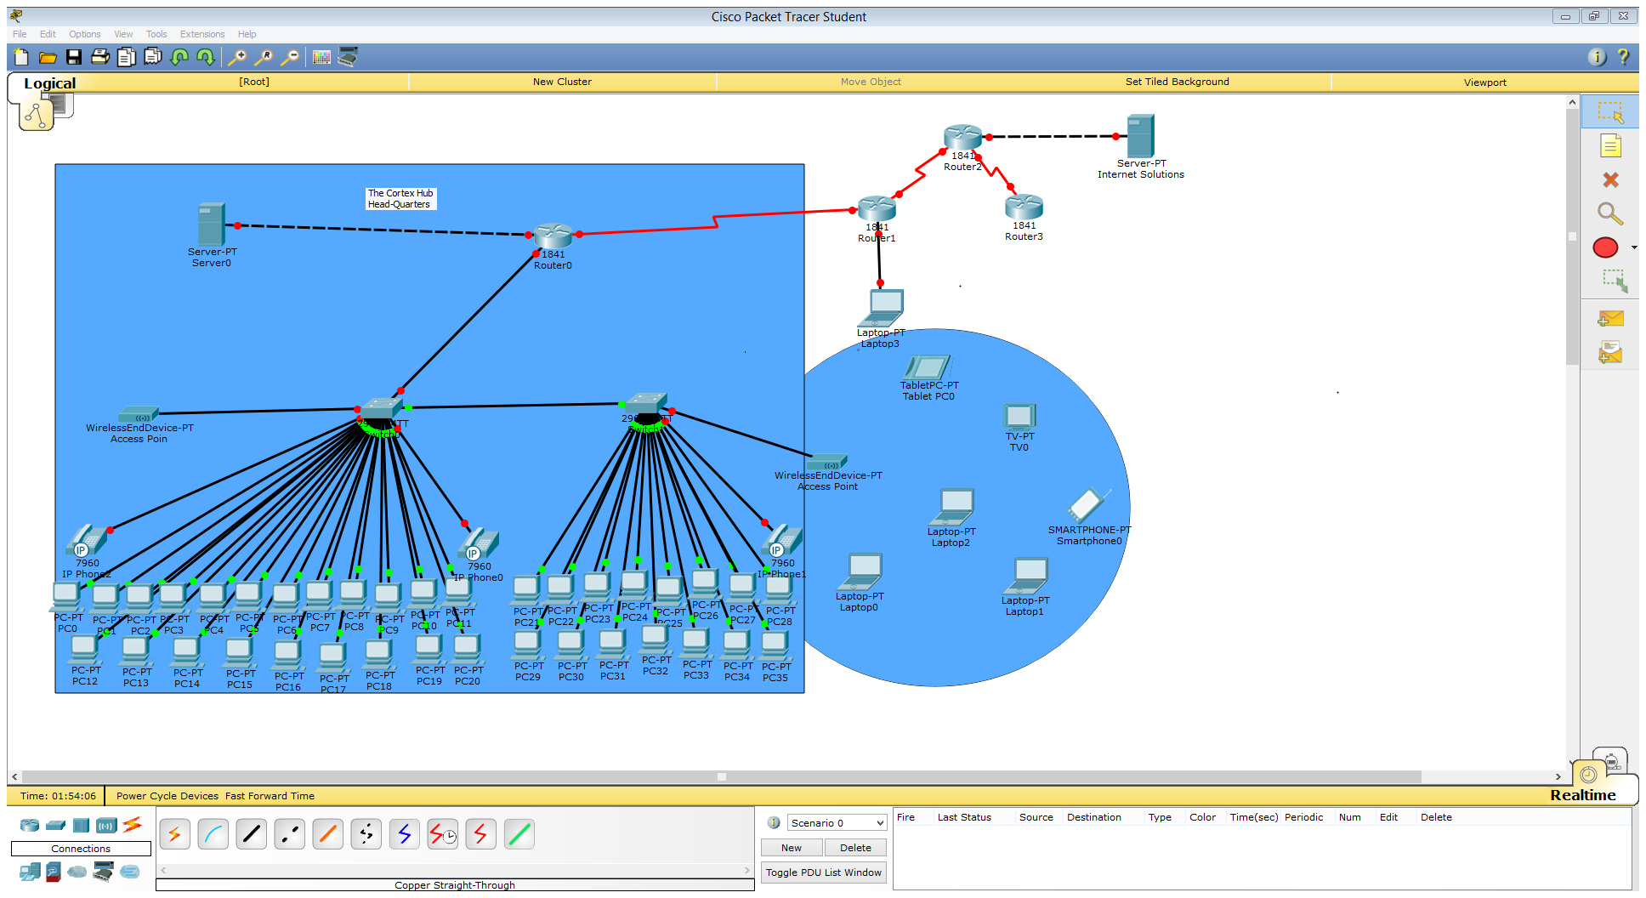

Traditional network is represented using Packet Tracer for implementing virtual network and connecting all the necessary devices.

Packet Tracer provides simulation, visualization, and authoring, assessment, and collaboration capabilities of complex technology concepts.

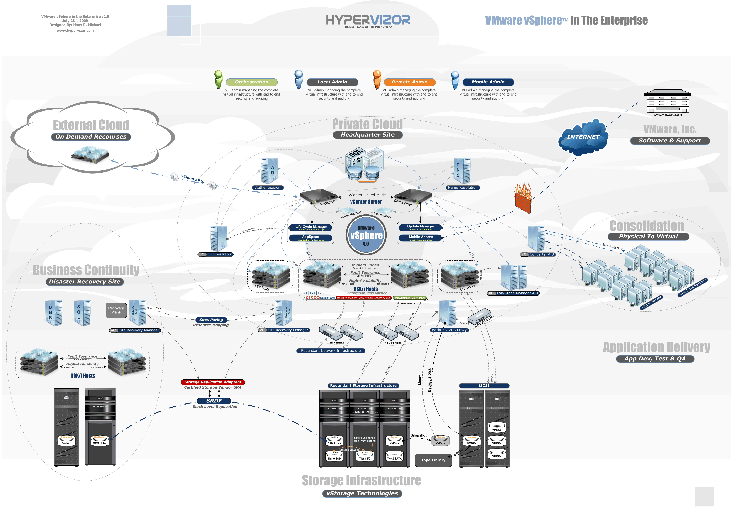

The network after the implementation of NFV will be an environment that has less wiring and with less physical hardware. The implementation of NFV will allow the network to be scalable and

# NFV LIMITATIONS

The challenge with NFV is that even though network functions are virtualized, you still need to configure a number of network devices. Network virtualization provides an abstraction of the virtual network from physical appliances via a high-speed physical switch fabric so that no physical rewiring is needed. The virtual network is a container of network services provisioned by software, very similar to a VM operational model (CPU, memory, I/O etc.). This virtual network also facilitates the mobility and adjacency of virtual servers in the network. Note that network virtualization is sometimes associated with SDN because a network controller who understands how the networking devices are connected and how to configure them is present. In addition, network virtualization may be complementary to NFV if network services are delivered on virtualized servers.

SDN on its own--that is the separation of control versus data plane, does not inherently provide operational simplification. Similarly, while NFV has a number of benefits because of the virtualization elements, operational simplification may not be achieved because of the need to touch multiple virtualized devices. Network virtualization in contrast, even without SDN and NFV, delivers significant operational efficiencies.

Network virtualization delivers a number of benefits, but there are also numerous impacts on security that must be considered. In fact, the risks are greater in the virtualized environment, as the number of attacks and virtual services is increasing, there are less physical protections in place, and the platform is still evolving and not as robust or defined like good old fashioned telecom iron.

Virtualization is another dimension that is introducing new security requirements into the enterprise. You can no longer be certain where application functions are taking place now various elements are being pushed into the cloud. Organizations must evaluate every aspect of the data and its protection the exact same way as they would in non-virtualized environments.

How and where is your data moving? Which external companies are allowed access to IT systems through federation? Who has control of your encryption and the keys for your encryption? Do mobile applications that run on employee devices in a BYOD environment pose a risk for data exposure? Service providers must double down on data protection in a virtual environment.

Additionally, traditional security policies don't match the traffic flows of a virtualized environment. Since network virtualization facilitates movement of virtual servers, it is paramount that a network security solution has the capability to set dynamic policies. These policies should be updated seamlessly when virtual workloads move around.

## TECHNICAL LIMITATIONS

Achieving high performance virtualized network appliances which are portable between different hardware vendors, and with different hypervisors. OSS/BSS development needs to move to a model in-line with Network Functions Virtualization and this is where SDN can play a role. Network Functions Virtualization will only scale if all of the functions can be automated. Ensuring the appropriate level of resilience to hardware and software failures. Integrating multiple virtual appliances from different vendors. Network operators need to be able to “mix & match” hardware from different vendors, hypervisors from different vendors and virtual appliances from different vendors without incurring significant integration costs and avoiding lock-in.

## OPERATIONAL LIMITATIONS

Achieving co-existence with hardware based network platforms whilst enabling an efficient migration path to fully virtualized network platforms which re-use network operator OSS/BSS. Managing and orchestrating many virtual network appliances particularly alongside legacy management systems while ensuring security from attack and misconfiguration. Prove that a virtual network is just as secure as a physical network.

# BUSINESS OPPORTUNITY

Service providers traditional sources of revenue, voice and video, are losing ground to services being provided over the top (OTT) on their data channels. While, the infrastructure needed to handle all that data traffic needs to grow to meet the expanding capacity requirements, it’s resulting in, infrastructure costs growing faster than subscriber revenue growth. Operators who try to respond with new ways to monetize their services are realizing that their networks are not agile enough to introduce new services more quickly.

# NFV TIME LINE

|  |  |
| --- | --- |
| **Research activity** | **Month** |
| Overview of study   1. Introduction to NFV 2. Background of Network Function Virtualisation 3. European Telecommunications Standards Institute(ETSI) 4. Benefits of Network Function Virtualisation 5. NFV Framework 6. Demonstrable implementation of NFV 7. Virtualizing the server functions into software 8. NFV VS SDN | MAY-05-2015-31/05/2015 |
| Research design: Week1    1) Deep Research on the topic  2) Network Virtualization Basics  3) Network Virtualization Defined | 30MAY-05-2015 TO 04MAY-05-2015 |
| Week 2  1) Benefits of Network Function Virtualisation  2) NFV vs SDN | 04MAY-05-2015 TO 12MAY-05-2015 |
| Week 3   1. Ideas behind Network Transformation 2. Network Virtualization Survey 3. Enablers for Network Functions Virtualization | 12MAY-05-2015 TO 18MAY-05-2015 |
| Week 4  1) Network Virtualization (NV) vs. Network functions virtualization (NFV)  2) Key attributes in evaluating solutions  3) NFV requirements | 18MAY-05-2015 TO 25MAY-05-2015 |
| Week 5  2) Network Functions Virtualization (NFV) Applied   1. A working, demonstrable implementation of NFV by virtualising the server functions into software. | 25MAY-05-2015 TO 31/05/2015 |
| Findings | 31/05/2015 |
| Conclusion | 28/05/2015 |
| Hand in complete project | 31/05/2015 |
| Make corrections |  |
| Have project paper edited and make corrections |  |